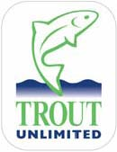Georgia Council of Trout Unlimited
Charlie Breithaupt, Chairman 194 Kitchins Lane. Clayton, GA 30525
December 3, 2005

RE: Position Statement on Upper Chattooga River – Visitor Use Capacity Analysis for Boating Ban
BACKGROUND: The Chattooga River is the upstate boundary between South Carolina and Georgia, and its headwaters are in North Carolina. The Chattooga was designated by the U.S. Congress as a Wild and Scenic River in 1974.
In March 1976 the Chattooga Wild and Scenic Development Plan was published in the federal register. This plan prohibits boating the Upper Chattooga River above Highway 28 with the following statements being made: “The recent increase in floaters using the river have had a detrimental effect on the fishing experience. Conflicts have developed on certain sections of the river where floaters and fisherman use the same waters. This location (Nicholson Fields) is the source of some of the best trout fishing in both South Carolina and Georgia. Floating will be prohibited above Highway 28 which includes the Nicholson Fields area.”
In January 2004, the Forest Service revised its plan to manage the Sumter National Forest, including the Chattooga River. That plan, signed by the agency’s Regional Forester in Atlanta, allowed floating to continue only on portion of the river downstream from the Highway 28 Bridge. Boating organization American Whitewater appealed that portion of the plan to the Forest Service’s Washington Office. In April 2005, the Reviewing Officer for the Chief of the Forest Service decided to send that part of the plan back to the Regional Forester and the Sumter National Forest for additional work. While the appeal decision does not direct that the decision be changed, it does direct the forest to conduct additional analysis regarding social and natural resource impacts on the river and to involve affected and interested parties. The Sumter National Forest is leading the reanalysis, working closely with two other national forests that share the river: the Chattahoochee National Forest in Georgia, and the National Forests in North Carolina.
POSITION STATEMENT: The Forest Service planners had the proper solution for angler-boater conflict resolution in 1976 and ‘zoning’ by maintaining the boating ban is still the proper solution today. It has achieved solitude and harmony for visitors on the Upper Chattooga for almost 30 years. This unique solitude experience is shared without conflict among traditional backcountry visitors such as anglers, hikers, backpackers, bird watchers, swimmers, waterfall viewers, and nature lovers. There is nowhere else anglers can go in the East that has the size and volume to permit quality fly-fishing in a spectacular backcountry setting that is boating-free. The backcountry visitors want to preserve the unique resource of solitude and protect the natural resources of the only section of the Chattooga that has not been damaged by conflict and management for too many user groups. ‘Zoning’ the space to ensure physical separation of visitors with differing and conflicting ways of experiencing the river and the environment is proper management; and it is also what is best for the future of the Upper Chattooga River.
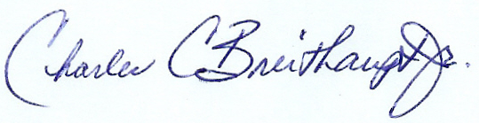
Charlie Breithaupt Chairman

